Pharmacy Enterprise Customization System (PECS)

Release Notes



Version 6.1

July 2017

Department of Veterans Affairs

Office of Information and Technology (OI&T)

Table of Contents

1. Introduction 1

2. Purpose 1

3. Audience 1

4. This Release 1

4.1. New Features and Functions Added 1

4.2. Enhancements and Modifications to Existing 2

4.3. Known Issues 2

5. Product Documentation 2

# Introduction

The goal of the Pharmacy Reengineering (PRE) project is to replace the current M-based suite of pharmacy applications with a system that will better meet the current and expected business needs for the Department of Veterans Affairs (VA) and address the ever-changing patient safety issues. PRE is intended to build on the work accomplished in 2006 with the development of the Pharmacy Enterprise Product System (PEPS) Proof of Concept (POC). The first phase, PRE V.0.5, implemented enhanced order checking functionality utilizing Health*e*Vet (H*e*V) compatible architecture and First Databank (FDB) MedKnowledge Application Program Interfaces (APIs) and database. The Pharmacy Enterprise Customization System (PECS) is a component of PRE that is intended to customize the FDB MedKnowledge Framework COTS database in order to integrate VA custom records. A process to automatically update the standard and custom FDB data at the local database has also been provided.

In response to the Project Management Accountability System (PMAS) initiative instituted in the summer of 2009 that requires projects to complete an increment every six months, PRE now uses an Agile Development methodology, which focuses on developing a usable product at the end of small, iterative timeframes, with involvement and approval from the product owner at every iteration. Each small timeframe, called a sprint, ends with a workable product that is built on the previous efforts until the increment is complete and meets the PMAS schedule. Each increment produces agreed-upon functionality that is available to the entire user community upon National Deployment.

This Release Notes document provides a brief description of the 2FA Implementation of PECS v6.1.00.

# Purpose

These release notes cover the changes to Pharmacy Enterprise Customization System (PECS) for this release.

# Audience

This document targets users and administrators of Pharmacy Enterprise Customization System (PECS) and applies to the changes made between this release and any previous release for this software.

# This Release

The following sections provide a summary of the new VA Mandate on 2FA authentication, as well as any fixes made to the existing software, Pharmacy Enterprise Customization (PECS) v6.1.00.

## New Features and Functions Added

The following are the changes in PECS v6.1.

PECS v6.1 builds on the functionality provided by PECS v.6.0.01. Additional changes includes:

* Implement the two factor authentication (2FA) for which PECS application code and configuration have been updated to work with the IAM SSOi service for user authentication. The user roles management code in PECS has also been modified to remove dependency on the VistA Security keys for user authorization and use the PECS database tables to store and manage user roles within the PECS application.

**Figure 1 – SSOi Central Login Page**

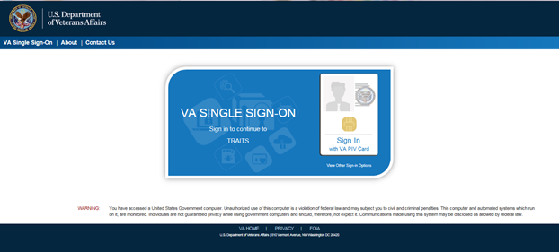

* Fix code to address the SFTP connection error which occurs when Centrify is implemented on the SFTP server and the server is joined to Active Directory.

## Enhancements and Modifications to Existing

No changes were made to the existing functionality of the application.

## Known Issues

None.

# Product Documentation

The following documents apply to this release:

* PECS System Design Document
* PECS Patch Description Document